AWS Elastic Container Service Access Guide

Input Guide
This section outlines the input parameters required for provisioning an AWS ECS Cluster and running tasks within it using the DASH portal. The setup is configured to run on AWS Fargate, providing serverless container management without the need to manage EC2 instances. Each parameter includes a description, available options, usage guidance, and notes on valid combinations when applicable.

Input Parameter | Description | Values Provided | Value Guidance | Valid Combinations
container_name | Name of the container to be launched as part of the ECS task. | Any alphanumeric string. | Use clear naming conventions for effective container management. | N/A
region | AWS region where the ECS cluster and tasks will be provisioned. | us-east-1, us-west-2, eu-west-1, ap-south-1, us-west-1. | Choose the region that is geographically closest to your end users or integrated services to minimize latency and improve performance. | N/A
os_type | Operating system type for the task. | Options:  Linux, Windows | Choose based on your workload requirements. | N/A
memory_in_mb | Amount of memory (in MB) allocated to the ECS task. | 1024, 2048, 4096, 5120, 6144. | Choose the amount of memory to allocate to the task to ensure reliable performance. | N/A
cpu | Number of CPU units allocated to the task. | 256, 512, 1024, 2048, 4096. | Choose based on your workload requirements. | N/A
cluster_name | Name of the ECS cluster where the service and tasks will run. | User defined string. | Use unique naming conventions for easier cluster management. | N/A
image | Docker image (from ECR or Docker Hub) used to run the container. | Container image. | Use repoName/imageName:tag for Docker Hub images, a full URI for other registries, and provide credentials for private registries. | N/A
port | Container port to be exposed for application traffic. | Port number of the container. | Define the port number the application listens on. | N/A
desired_task_count | Number of tasks the ECS service should always keep running. | Count:  1, 2, 3, 4, 5 | Choose based on workload requirements. | N/A
service_name | Name of the ECS service managing the tasks. | Any alphanumeric string. | Use a clear and consistent format. | N/A
task_name | Name of the ECS task definition(A task definition is the blueprint that tells ECS what containers to run and how to run them). | Any alphanumeric string. | Use a clear and consistent format. | N/A
owner | The team or individual responsible for maintaining the cluster. | Specify the team name or individual responsible for maintaining the cluster. | Provide correct team/individual name. | N/A
application | Name of the application running inside the container. | Enter the application name running as a container. | Provide the application name. | N/A
project | Project to which the ECS cluster and tasks are associated. | Indicate the project or initiative name related to the cluster. | Provide the project name. | N/A
deployment | The target environment (e.g., development, testing, prod) where the cluster will be provisioned. | Define the deployment environment name (e.g., dev, test, prod) | Choose the environment where the cluster has to be deployed. | N/A
Services expire after 30 days. Create this service now, or schedule for a later date? | ECS Cluster will be deleted 30 days after creation, or it can be scheduled to be created at a later date. | Create Now (or)  Schedule for Later | Choose based on cluster requirements. | N/A

Sample Input Selection:
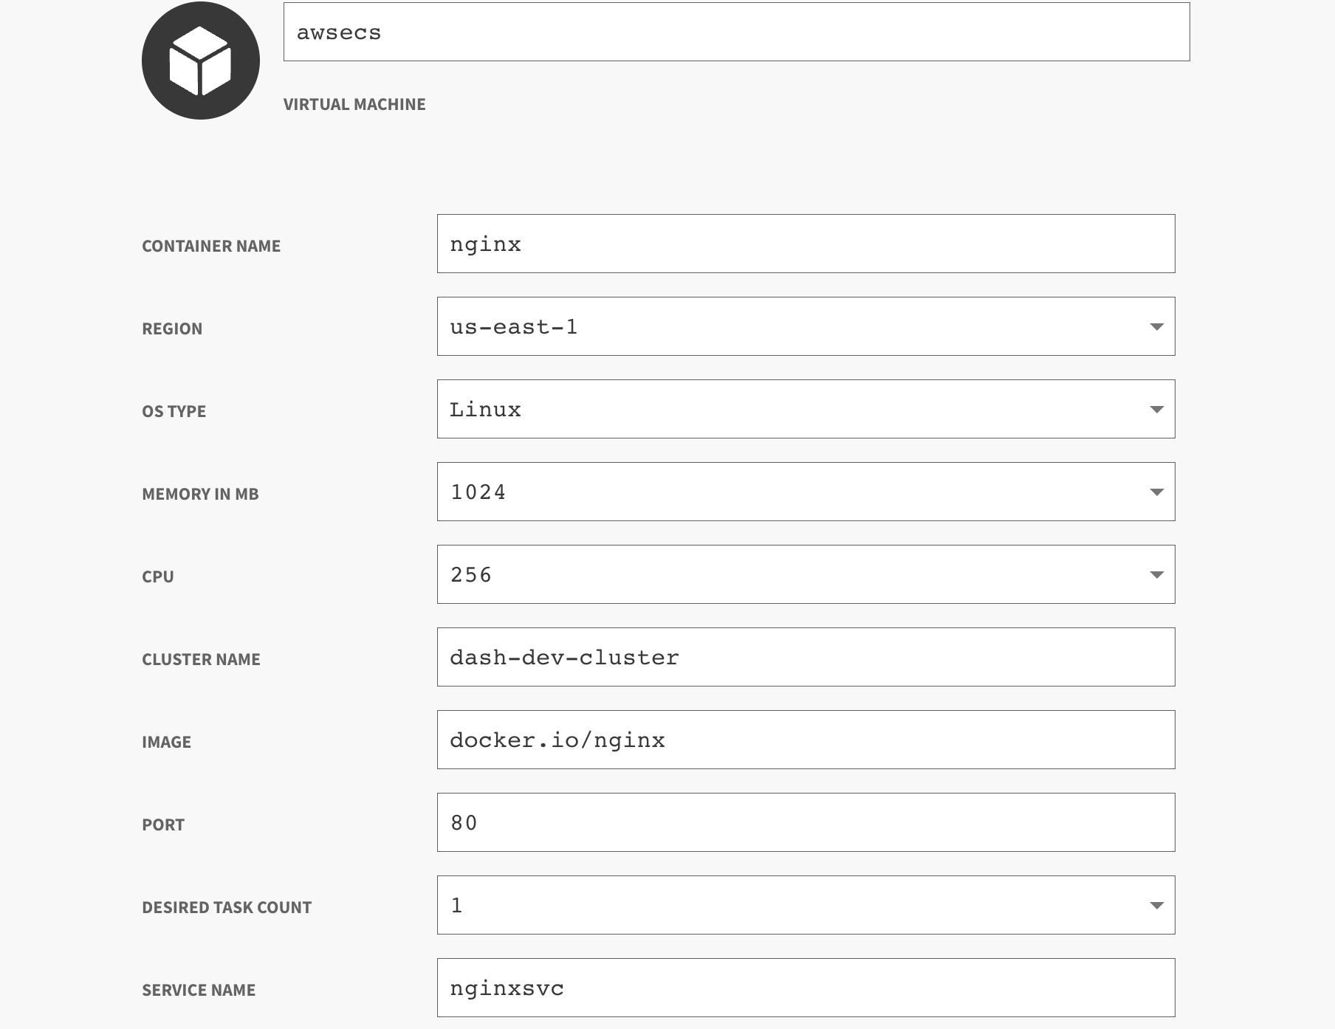
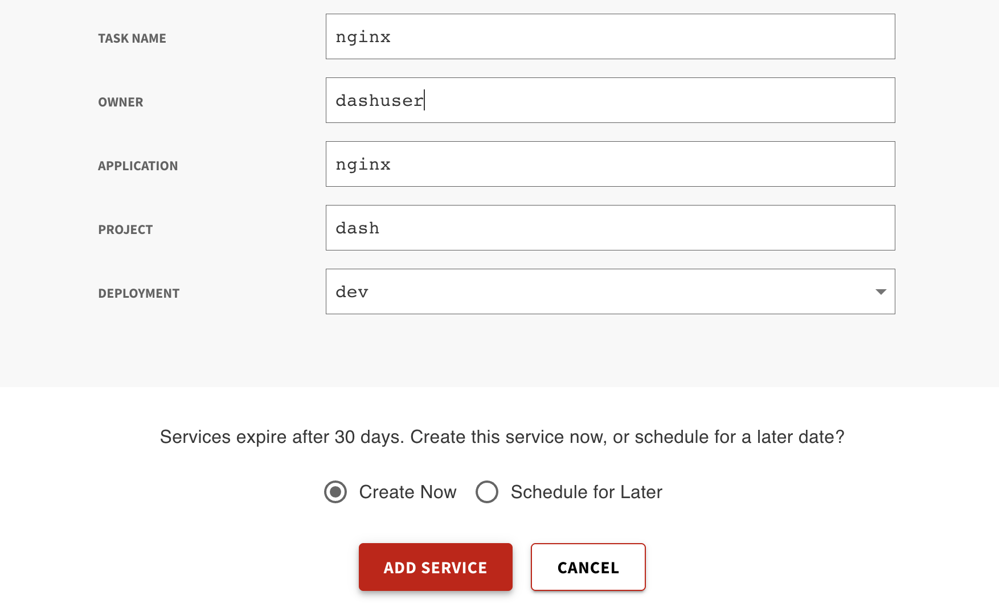

Output Guide
This section outlines the output values generated after ECS Cluster and task provisioning through the DASH Portal. These outputs can be used to access the containerized application.

Output | Description | Example Value
alb_dns_name | Load Balancer DNS to access the application from the browser. | dash-alb-43s1-726678657.us-east-1.elb.amazonaws.com

Note: Since a CA certificate is not attached to the Load Balancer, the application should be accessed using HTTP.
Example: http://dash-alb-43s1-726678657.us-east-1.elb.amazonaws.com

